**Barron’s Let’s Review Regents – Algebra I**

# Chapter 12: Regression Curves

## 12.1 Line of Best Fit

Two points can always be joined with a line. If there more than two points, there may not be one line that passes through all of them. If we need a linear equation for a line that comes close to all the points, there is a feature of the graphing calculator that will calculate the slope and y-intercept of this line.

|  |  |
| --- | --- |
| **Temperature** | **Number of people at the beach** |
| 30 | 5 |
| 40 | 21 |
| 50 | 45 |
| 60 | 65 |
| 70 | 77 |
| 80 | 102 |
| 90 | 129 |

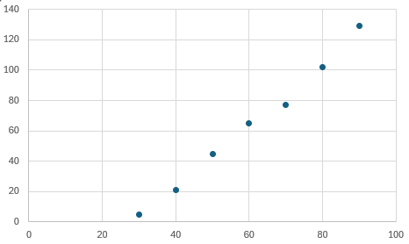

A line drawn through any of the two points will come close but will not pass through any of the other points.

Though there is not one line that passes through all the points, there is a *line of best fit* that will come close to all points. The equation for the line of best fit will be useful in calculating approximate coordinates for other points on the line.

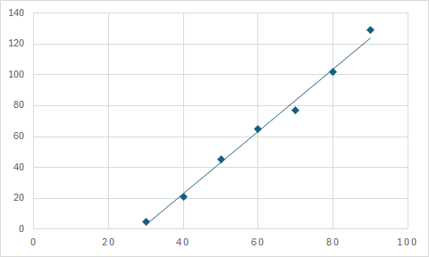

Line of Best Fit with Equation

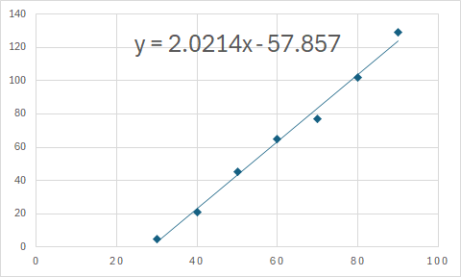

**Using the Line of Best Fit to Answer Questions About the Real-World Scenarios**

Approximately how many people will be at the beach when the temperature is 100 degrees?

Approximately 144 people will be there when it is 100 degrees.

At what temperature will there be 100 people on the beach?

At a temperature of approximately 78 degrees, there will be 100 people at the beach.

### Check Your Understanding of Section 12.1

1. Multiple-Choice
2. Calculate the equation for the line of best fit for the following set of data in form. Round *m* and *b* to the nearest tenth.

|  |  |
| --- | --- |
| x | y |
| 1 | 3 |
| 2 | 5 |
| 3 | 4 |
| 4 | 6 |
| 5 | 8 |

1. **y = 1.1x + 1.9**
2. Calculate the equation for the line of best fit for the following set of data in form. Round *m* and *b* to the nearest tenth.

|  |  |
| --- | --- |
| x | y |
| 1 | 7 |
| 2 | 6 |
| 3 | 6 |
| 4 | 5 |
| 5 | 4 |

**(4) y = -0.7x + 7.7**

1. Calculate the equation for the line of best fit for the following set of data in form. Round *m* and *b* to the nearest tenth.

|  |  |
| --- | --- |
| x | y |
| 1 | 1 |
| 2 | 3 |
| 3 | 8 |
| 4 | 7 |
| 5 | 9 |

1. **y = 2x - 0.4**
2. Calculate the equation for the line of best fit for the following set of data in form. Round *m* and *b* to the nearest tenth.

|  |  |
| --- | --- |
| x | y |
| 1 | 4 |
| 2 | 3 |
| 3 | 5 |
| 4 | 4 |
| 5 | 5 |

**(3) y = 0.3x + 3.3**

1. Calculate the equation for the line of best fit for the following set of data in form. Round *m* and *b* to the nearest tenth.

|  |  |
| --- | --- |
| x | y |
| 2 | 16 |
| 4 | 12 |
| 6 | 2 |
| 8 | 6 |
| 10 | 2 |

1. **y = -1.7x + 17.8**
2. Calculate the equation for the line of best fit for the following set of data in form. Round *m* and *b* to the nearest tenth.

|  |  |
| --- | --- |
| x | y |
| 10 | 33 |
| 20 | 20 |
| 30 | 10 |
| 40 | 14 |
| 50 | 6 |

**(2) y = -0.6x + 34.6**

1. Calculate the equation for the line of best fit for the following set of data in form. Round *m* and *b* to the nearest tenth.

|  |  |
| --- | --- |
| x | y |
| 10 | 250 |
| 25 | 310 |
| 37 | 450 |
| 46 | 560 |
| 59 | 820 |

**(3) y = 11.5x + 69.8**

1. What is the equation for the line of best fit for the points on this scatterplot?

|  |  |  |
| --- | --- | --- |
|  | x | y |
| A | 2 | 1 |
| B | 4 | 5 |
| C | 6 | 3 |
| D | 8 | 7 |
| E | 10 | 9 |

**(4) y = 0.9x - 0.4**

1. Of these four choices, which line appears to be the best fit for this scatterplot?  
   **(3)**
2. The equation is a line of best fit for which scatterplot?  
   **(1)**
3. *Show how you arrived at your answers*.
4. A bird-watching group tracks the number of birds they see and the temperature for six different locations. The data are collected in the table below. (a) Make a scatterplot of the data. (b) Calculate the line of best fit that relates birds (B) to temperature (T). Round values to the nearest hundredth. (c) Use your equation of the line of best fit to predict how many birds they would see if the temperature was 55 degrees.

|  |  |
| --- | --- |
| **Temperature** | **Birds seen** |
| 40 | 30 |
| 50 | 41 |
| 60 | 72 |
| 70 | 91 |
| 80 | 94 |
| 90 | 89 |

**  
**(b)   
(c) or approximately 56 birds**

1. A car dealership keeps track of how many cars it sells at different prices. The data are collected in the table below. (a) Make a scatterplot of the data. (b) Calculate the line of best fit that relates cars sold (C) to price (P). Round values to the nearest hundredth. (c) Use your equation of the line of best fit to predict how many cars the dealership would sell at a cost of $31,000.

|  |  |
| --- | --- |
| Price (in thousands of dollars) | Cars sold |
| 25 | 150 |
| 30 | 127 |
| 35 | 118 |
| 40 | 91 |
| 50 | 65 |

**(a)**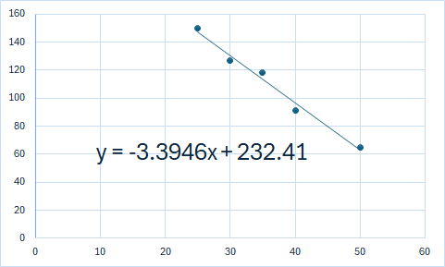  
**(b)   
(c)   
Approximately 127 cars sold.**

1. How is it possible to find the equation for the line of best fit without a calculator?  
     
   Because the five points all lie on a line, the line of best fit is just the equation of the line through any of the two points. The equation is .
2. The two scatterplots below have all points the same, except the one on the left has the point (3,1) while the one on the right has the point (3,10). Will they have the same lines of best fit? If not, how will the line of best fit for the scatterplot on the left be different from the line of the best fit for the scatterplot on the right.  
     
   The scatterplot on the left with the point (3,1) will have a lower y-value on the y-intercept, and a greater slope, while the scatterplot on the right with the point (3,10) will have a higher y-value on the y-intercept and a slightly less increasing slope.